CSCI 230 EXAM 3 - Closed book/notes/neighbor!!

(1) Given the following key data for Binary Search Tree (BST) nodes: 5, 10, 15, 20, 25, 30, 35.

1.A. 10pts. What order would you insert these nodes so that the BST is perfectly balanced? Give the ordering and also draw the tree.

20, 10, 5, 15, 30, 25, 35 results in: 20
/ \
10 30
/ \ / \
5 15 25 35

1.B. 10pts. Give two examples of how you would insert these nodes so that the BST is completely out of balanced – essentially a linked list. Give the two orderings and also draw the trees.

5, 10, 15, 20, 25, 30, 35 5
And \
35, 30, 25, 20, 15, 10, 5 10
\
15
\ and opposite from 35 down to 5.
20
\
25
\
30
\
35

1.C 10pts. For one of your ordering examples in 1.B, show the inserts into a AVL tree. Show how the AVL tree changes after each insert.

5 5 5 10 10 10
\ \ / \ / \ / \
10 10 5 15 5 15 5 20 …..
\ \ / \
15 20 15 25
\
25

2. Recall the following code we wrote in class:

public class CRecord {

private int cnum;
private String email;
private String name;

// constructors, getter/setters, etc..
}

public class BSTNode {

private CRecord data;
private BSTNode left, right;

// constructors, getter/setters, etc..
}

public class BST {

private BSTNode root;

// constructors, getter/setters, etc..
}

2.A. 10pts. Write a method for the BST class that returns an integer: the number of CRecord’s in the BST with the name attribute being “Darth Vadar”. BE PRECISE AND WRITE VERY NEATLY.

public int countDarth(BSTNode current){ // must be passed this.root to start

if(current == null){
return 0;
}else if (current.getData().getName().equals(“Darth Vadar”)){
return 1+ countDarth(current.getLeft()) + countDarth(current.getRight());
}else{
return countDarth(current.getLeft()) + countDarth(current.getRight());
}
}

2.B. 15pts. Write a method for the BST class that returns the difference between the smallest and largest cnum in the BST. BE PRECISE AND WRITE VERY NEATLY.

public int diff( ){

BSTNode temp = this.root;
int L = 0, R = 0;
while(temp != null){
L = temp.getData().getCnum();
temp = temp.getLeft();
}
temp = this.root;
while(temp != null){
R = temp.getData().getCnum();
temp = temp.getRight();
}

return R-L;

}

2.C. 15pts. Write a method for the BST class that takes an integer argument and returns void. The method removes a CRecord from the tree is the integer argument is a cnum in a CRecord inside of a leaf node. (A leaf node is one that does not have any children nodes.) BE PRECISE AND WRITE VERY NEATLY.

public void removeLeaf(int cnum){

BSTNode current = this.root;
BSTNode previous = null;
if(current != null){
boolean done = false, left = false;
while(!done){
if(current.getData().getCnum() == cnum){
if(current.getLeft() == null && current.getRight() == null){
if(previous == null){
done = true;
}else if(left){
previous.setLeft(null);
}else{
Previous.setRight(null);
}
done = true;
}
}else if(current.getData().getCnum() > cnum){
left = true;
previous = current;
current = current.getLeft();
}else{
left = false;
previous = current;
current = current.getRight();
}
}
}
}

3. 10pts. What is a Big-O for the find( ) method in the following data structures. Be precise and say if there are any caveats to the Big-O. BE PRECISE AND WRITE VERY NEATLY.

Linked List:

O( n ) if nothing…

Binary Search Tree:

O( logn ) if the BST is balanced

Hash Table:

O( 1 ) if the number of collisions does not grow proportionally with n

4. 10pts. How are collisions resolved in an open hash table (adjacency lists) scheme? Describe it and draw a picture.

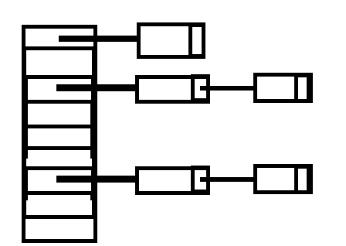
With linked list. Each index in the has table array
contains the head to a linked list that stored collisions.

5. 10pts. Why is it important to make the has table size a prime number?

So that patterns in the data keys don’t result in a high number of collisions.

6. 10pts. Given the following key data for an open hash table of size 10: 5, 10, 15, 20, 25, 30, 35. Draw the has table after all the inserts, assuming that the hash function is simply key mod table size.

